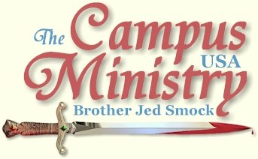
brojed.org
brojed@aol.com
573-999-0347 begin_of_the_skype_highlighting 573-999-0347 end_of_the_skype_highlighting
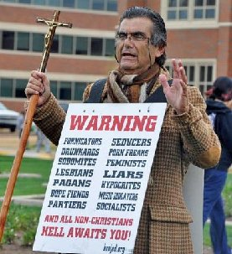
Prayer Requests: April 14th, Is Christianity True?, Debate with Dave the Atheist at Mizzou
April 15, Smock Semi-Annual Open House for the Students
Many seekers will be at both of these events!

SISTER CINDY BORING?
University of Oklahoma, March 28, 2011
The temperature was only 46 and windy and cloudy when we started. Nevertheless, I expected that we would get a crowd since Bro and I were here in December of 2009 when it was much colder and we still drew a lot of hearers.
Cindy gathered a crowd in front of Dale Hall on the mall. A group of Asian students, whom I assumed were Japanese, were raising money to help Japan. [Later Sister Pat informed me she had talked to one of them and he was Vietnamese.] A few of them interrupted Cindy, but she just ignored them. To my surprise the crowd died out within 15 minutes after the break. I blamed the cold weather. I have rarely seen Cindy loose a crowd.
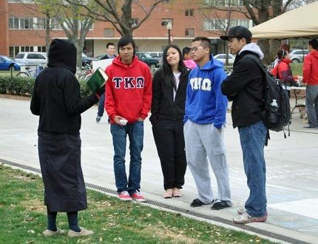
Sister Pat witnessing to the Vietnamese who were raising money for Japan.
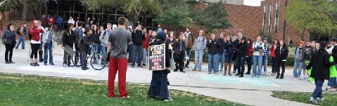
The Crowd that Left
I started again at the next break and drew another crowd. After the break a policeman told the students that they could not stand in the bike lane. The students complied and moved to the middle of the sidewalk. I feared they would not stay there. So I called them to follow me to the center of the mall. I did not want the police coming back and being given an excuse to break up the meeting. The students followed me to the middle of the mall. As the hour progressed I built up the crowd. With the cold weather, I figured that sex talk would hold their attention. Two sodomites, one of whom was an Englishman, vigorously defended their sin. The student newspaper ran an editorial today headlined, “The Bible Does Not Condemn Homosexuality.” So the issue definitely needed to be addressed.
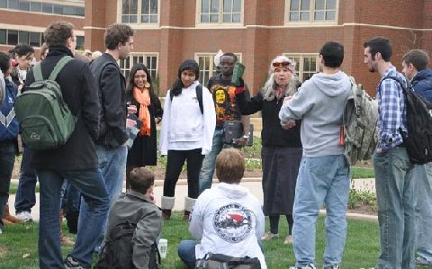
Sister Pat at OU
After an hour Cindy returned from inside Dale Hall where she and the rest of the team had taken refuge from the weather. Much to my surprise Cindy lost about three fourths of the crowd. I heard one student say as he left, “She is boring.” I never heard anyone accuse Cindy of being boring before. [Mind you, years ago at the University of Minnesota the chairman of the Dept. of Communication said to me, “Your wife is the greatest communicator that I have ever heard.”] Of course, Cindy was not really boring but sometimes a crowd is attached to a particular speaker, which can make the transfer of speakers difficult. Still Cindy maintained a group of 12-15 listeners. Shortly after 4 PM Sister Pat took over. She built the crowd up to about 25. She reported that she had a very good hour. The two homos from earlier in the afternoon returned to argue with Sister Pat. She gave them no quarter.
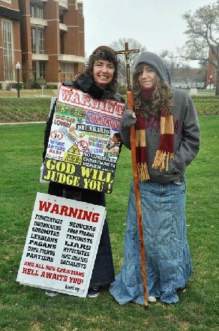
Sister Cindy and Priscilla before the meeting starts at OU
Meanwhile, a student asked me on the sidelines, “Can one be a Christian and not go to church?” I responded, “Can one get an education without going to school?” Perhaps, but it is helpful to go to school.” He said he was a Christian but as a result of listening to us he decided that something was missing.
Shortly before, I had renewed fellowship with Grant K. with whom I have had many discussions concerning the five points of Calvinism in the past. We have argued these issues not only on campus but also on my old website board and over facebook many times. He indicated that now he better understood my positions on original sin and Christian perfection and he was not in such vehement opposition as he had been in the past. I called Grant over to introduce him to the student who was churchless and was not involved in any Bible studies to see if Grant could give him some direction. Grant gave him his contact information and quizzed the student concerning his experience with the new birth. Pat then turned her group back over to me. I spoke about 10 minutes then Grant came over to help defend the faith. Since it was after 5 PM, I decided to let Grant take over. When we left campus, Grant was arguing with a group of 10. I like to get students that know something about the Bible and understand the times an opportunity to get involved and known on campus.
We considered it a fruitful day, especially considering the cold weather.
Today, I received the following facebook message from Russel M.: “In the spring of 1980 you identified me as the worst sinner on the campus of Univ. of NM, you were probably right. I am today a Christian and have repented.”
THE GREEN HORNETS
University of Oklahoma, March 29, 2011
Today was colder than yesterday, only 43 degrees when we started and cloudy and windy. Sister Cindy, Martha and Priscilla stayed in the motel on account of the weather. Sister Pat was a good soldier to brave the elements.
The first fellow that stopped claimed to be bisexual. Yet he said he only had sex with one woman, but he was attracted to men. He said his father was a preacher. I suggested that his father must be grieved by his sin. Then he said his father had molested his sister. He finally left, then several others gathered. For a long while we only had a small group listening. They left around 2 and I decided I would give it one last shot thinking we had done enough for a cold day and we were not likely get a crowd. I was looking forward to going back to the warm motel room and taking a nap. I was sort of hoping that no one would stop so that I could say, “Well, we tried, but it was just too cold.”
But students began to re-gather despite the cold. At this point Sister Pat went inside to escape the elements. And my sign listing sins was left unguarded and consequently it was stolen. It was my best attention getting sign. So I had my chair, staff and my colored sandwich board to watch. It was difficult to keep track of all the stuff. The wind was blowing my sign, which made it difficult to wear. Sister Pat was too cold to come back out.
Around 3 PM there was a large class break and I collected a crowd of 50-75, which stayed with me for over two hours. One Christian girl was a persistent little pest, who kept interrupting me. The first time I allowed her to give her testimony. Afterwards, whenever she interrupted, I lifted my voice above hers. A few times she walked away and urged the crowd to listen to her at distance from me. But she could not hold a crowd very long before they all returned to listen to me. Also, three perverts in green body suits arrived and were harassing me, making sexual moves very close to me and sometimes touching me and trying to possess my chair. Between the girl and these green hornets and the cold weather preaching conditions were very difficult. The police finally came out and one policeman gave a good short speech to the crowd that everyone ought to be able to express themselves and that the students should give me some space. It was so hectic for over an hour that all I could do was to stand my crowd and repeatedly call the students to repentance and faith. I could not get into any in depth teaching.
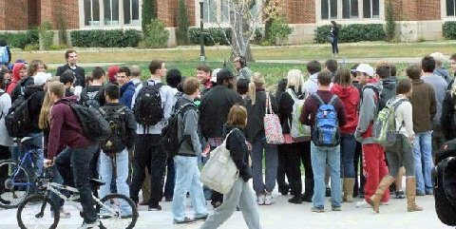
The Crowd that Didn't Leave!
The girl and the hornets finally left after 5 PM. And I had a good session with 12-15 students on apologetic issues until 6 PM. I was happy that Sister Pat and I went out today and that I did not let the weather get the best of me. It was frustrating to lose my sign.
One bisexual gal who listened for a few hours said her dad listened to me at the University of Wisconsin back in the 80’s. He said that I was egged on campus and that I deserved kudos for not losing my temper.
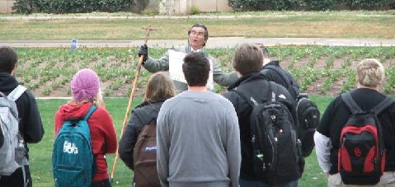
"...Between the girl and these green hornets and the cold weather preaching conditions were very difficult."
HYPOCRITES PLEADING FOR SIN
University of Central Oklahoma, March 30, 2011
This is my second visit to this campus. Bro and I preached here in December, 2009. I had forgotten that one is supposed to get a “utilization permit” through the Department of Student Life. Shortly, after I started a male passed by and claimed that Jesus has done a perverted act upon him last night. He used the grossest of terms to describe the act. I hesitate even to mention this but readers need to know how deep some students have fallen, right here in the buckle of the Bible belt. Of course, I rebuked him sharply. Within 10 minutes two policemen informed me that I could not continue “advertising” until I got the required permit.
I procured the permit without any problems and within fifteen minutes was preaching again. Down the sidewalk from where I was speaking a number of tables were set up representing campus counselors (non-academic) most of whom are useless. I soon had a lot more interest than they did because I was counseling from a Biblical perspective. The uncompromised word of the Lord will usually draw a lot of attention.
The crowd was very lively and most of the students professed to be Christians. One atheist held a sign which said, “It is OK not to Pray.” Cindy pointed out that it is OK for most of the students not to pray until they are willing to pray a prayer of repentance, which is the only prayer that God has promised to hear from a sinner. Virtually all the Christians were defending sin. First John 1:8 was read many times and several others brought up Romans 7. Cindy and I alternated the preaching. The weather was still cold and cloudy today but not so windy. Sister Pat stayed at the motel and Martha and Priscilla would only come out of the University Center to take pictures.
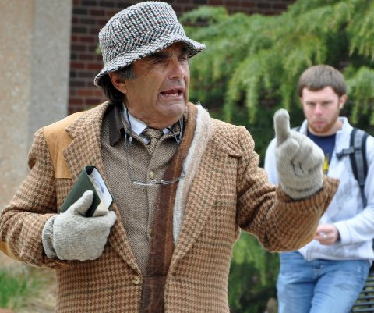
At OCU, "Virtually all the Christians were defending sin."
About 2 PM as Cindy was preaching, a policeman wanted us to move from our designated area since a children’s playground was nearby. I suppose it was some campus day care facility. We complied. It is always a good test as to how much we have captured the attention of the students to see if the crowd will follow. We were moved about a half block away to the center of campus under a clock tower. The whole crowd followed us. The policeman informed me that this would actually probably be a better location, which proved to be the case.
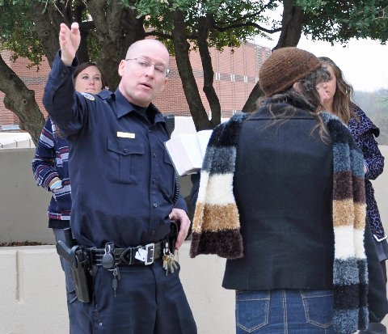
Policeman asks Sis. Cindy to relocate.
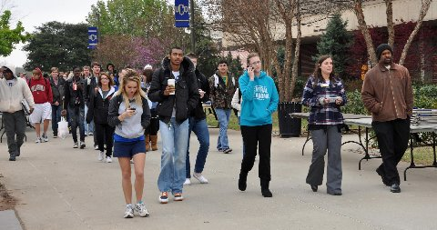
The crowd follows Sis. Cindy to the new location.
During our preaching there was a group of Christians praying much of the time. Cindy thought that they were supportive. Often professing Christians pray against us. The male who had said the vile thing about Jesus at one point kicked over my chair and walked off. A Christian picked it up for me. The police were present for most of the afternoon. This is largely a commuter campus of 18,000 students. I have not heard of other preachers visiting this campus. I suspect that our preaching was the biggest stir that they have had on campus since Bro and I visited.
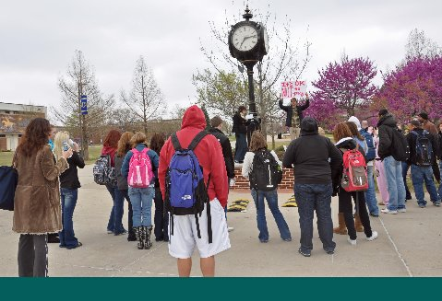
Guy with, "it's OK not to pray" sign tries to distract for the preaching.
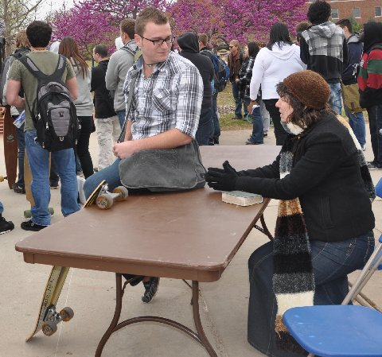
This student explained the he had left the church because of sin in his family. He had made a commitment to Christ in the church where his dad was music minister. They left when his mom ran off with a lesbian.
I concluded the meeting at 5 PM with a prayer. Initially, I could hear several laughing. But someone said, “Show some respect!” After this admonition suddenly everyone became quiet as I finished my prayer.
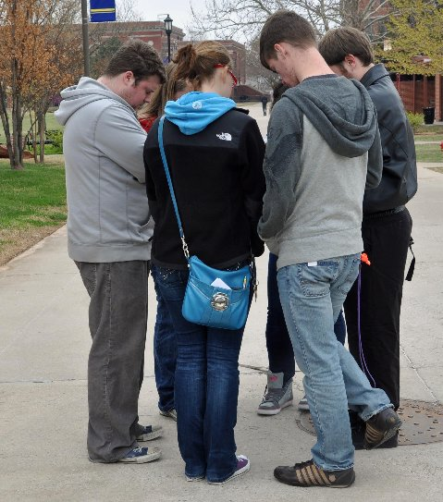
"During our preaching there was a group of Christians praying much of the time."
SOMETHING TO THINK ABOUT
University of Oklahoma, March 31, 2011
Cindy started the meeting and she had to contend with an atheist for most of her hour. A group of Moslems from Pakistan had reserved the area on the mall in front of Dale Hall, where we have been preaching. When I took my turn, the police informed me that I would have to move down the mall. I complied and the crowd followed me down the sidewalk. I was having a talk on socialism vs. capitalism with a thoughtful young man when several girls said they wanted to speak. I gave them permission. Their spokesman kept saying, “God is love. He is not wrath.” She kept repeating this. I finally asked, “Is there a Hell?” She said, “Yes, but God is not wrathful. He is love.” The fellow with whom I was having an intellectual discussion asked the girls, “Is God anything else besides love? Is that the only way to describe him?” The girl kept repeating, “God is love.” They never say that God is holy.

Atheist in white shirt.
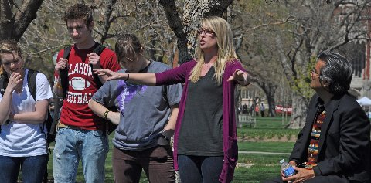
“God is love. He is not wrath,” group interrupts Bro. Jed.
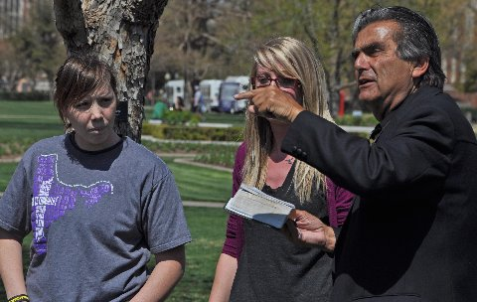
"They never say that God is holy."
When Cindy started preaching a fellow asked to play the trumpet. Cindy thought the timing was bad, but she went ahead and gave him permission since he seemed sincere. A girl named Reagan had been interrupting Cindy. She even kept talking when the guy wanted to play his trumpet. Cindy walked a hundred feet from the crowd and starting preaching again. The man played Amazing Grace and soon the crowd followed Cindy; however, several stopped to engage me in conversation. Cindy asked the crowd including Reagan, “What are you all doing here? I am preaching to the squirrels now.” Eventually, Cindy called upon me. Soon Reagan and other girls wanted to talk to me. I announced, “I am not talking to the girls. They have been interrupting like cackling hens, cluck, cluck, cluck.” Eventually, the girls told the crowd to follow them. I urged all the girls and homosexuals to go over and talk to Reagan. I said, “Men and lesbians can stay with me. I want to have man to man talk.”
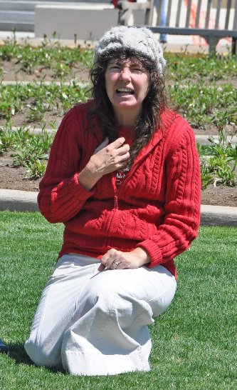
Sis. Cindy tells a story of salvation.
I preached until 6 PM. Then I noticed Rachael with whom I had an appointment for an interview at 4:15. But I had been tied up in preaching for two hours. I turned the meeting back to Cindy. Rachel was a Christian girl who had transferred from a Christian College to OU. She is doing a story on me for the year book. I gave her 30 minutes. Yearbook stories are good because they will be read and reread for a lifetime. I have been featured in many Yearbooks over the years.
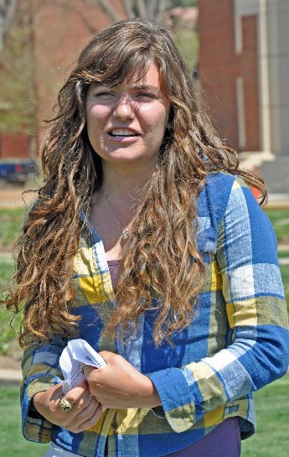
Martha Marie tells the story of HPV Holly
Sister Pat had the largest crowd of the afternoon. As she was speaking, a young man approached me with his hand extended and said, “Brother Jed, I am a senior and I have been listening to you since I was a freshman. Every time I listen you give me something to think about. Thank you for coming to campus.” I asked if he had committed his life to Christ. He said that he had not, but that he was considering doing that.
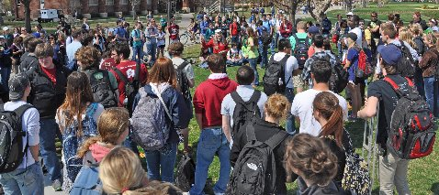
Sister Pat delivers the Gospel to a large crowd.
Martha and Priscilla had students talking with them for much of the afternoon. One of them was Alee, the girl who kept interrupting on Tuesday. She told the girls that she liked me and thought what I was doing was “awesome.” She complained that she could not figure out why I would not address her questions the other day. Maybe I will have a personal conversation with Alee tomorrow. I saw her hanging around today and she was better behaved.
We finally left campus at 7 PM. The weather got up into the low 70’s today and it was sunny, which was quite a relief from the last three days.
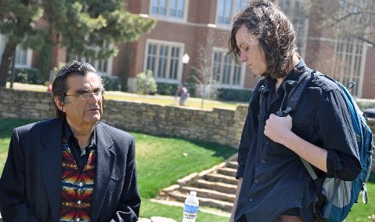
Sideline Discussion
LESBIANS’ MOUTHS ARE OUT OF PLACE
University of Oklahoma, April 1, 2011
I started at the end of a class break about 11:25. A group of mostly gays and lesbians gathered, which have been hanging around much of the week. I bantered with them for a while as more students slowly gathered.
By 12:30 we had a crowd of about 100. At one point a group of lesbians came running out to perform the Vagina Monologues. It may have been the grossest demonstration which I have ever heard or seen on campus, and I have seen a lot. The finale was when they started chanting the slang term for the vagina. The purpose was to get the crowd to repeat the word with them over and over. They succeeded in getting most of the crowd to chant the word. The purpose of this production is to desensitize women who might have any sense of modesty left and to influence males to cease respecting the women as “the weaker vessel.” One of the lesbians took off her shirt as she was prancing around, which was one of the ugliest sights which I have ever seen. One of the lesbians who was decently dressed and had pretty long red hair sat beside another short red haired lesbian on a bench and they kissed passionately for about 5 minutes. The lip stick lesbian is married to a male. When I asked if she had any babies yet, she lifted up her middle finger. Indicating one?
Despite this 15 minute interruption, the crowd was generally mellow and attentive today. And I at one point gave a simple gospel message. I said, “We have good news you may experience the forgiveness of sins and have a clear conscience and receive the gift of everlasting life through faith in the Lord Jesus Christ. I taught that sin is contrary to human nature and illustrated my point with a few stories.
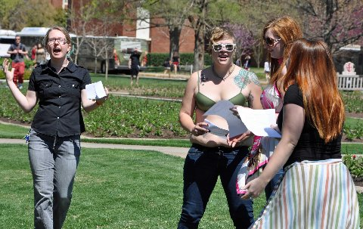
Lesbians interrupt with perverted skit
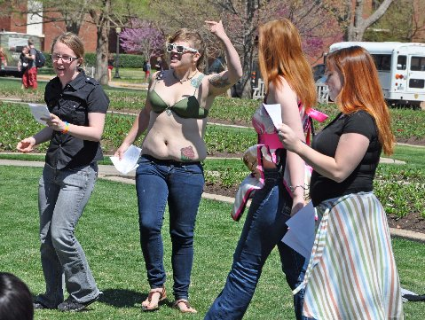
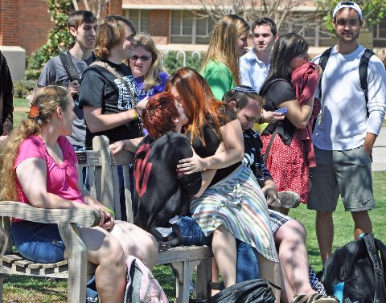
Only one Christian interrupted us today. He tried to speak over Cindy shortly after she took her first turn. Cindy got in his face and loudly commanded him to repent over and over, which is an old tactic, which I have not seen her use recently. He finally walked off to the side, and before long he was amening Cindy. She thought that some Christian girls put him up to it.
About 3:45 a “flash mob” came running up with their musical instruments and started playing rock music. I did not know that they were a “flash mob” (Prissy explained to me the term). I assumed that they would be there for a while so I walked away from the crowd to join Cindy and the girls. But they played one song and went running off. About a dozen students ended up coming over to ask more questions. We stayed another half hour. It was probably a tactical error on my part to walk away since it turned out that they were there and gone in a flash.
Cindy’s comment was, “It was “a wonderful, wonderful day.” I asked what she would like to add to my journal explaining the wonder of the day. Her answer was, “Same old, same old.”
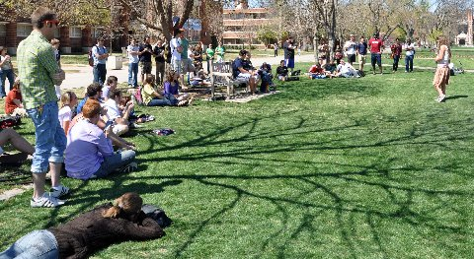
Martha does the "Sorority Girl that Met the Devil" skit.
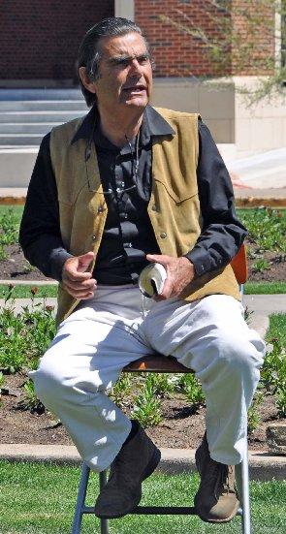
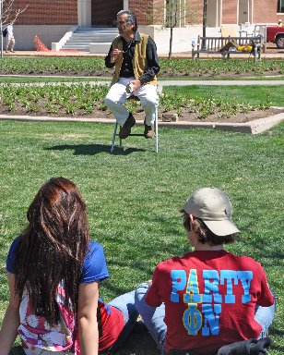
Thank you for your faithful prayers and support. Please continue to pray for us. You may donate to CMUSA using PayPal by going to our web site brojed.org or by mailing your check to our home address: CMUSA 2402 Longview Dr. Columbia, MO 65203. All gifts are tax deductible. Thank you for your generosity.
